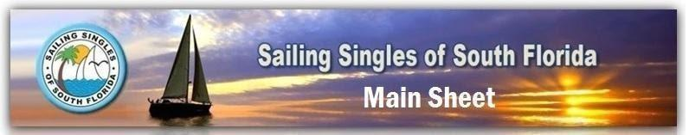**Volume XXXI Number 11 November, 2021**

|  |  |  |  |  |
| --- | --- | --- | --- | --- |
|  | [SSSF Facebook Page](https://www.facebook.com/Sailing-Singles-of-South-Florida-196881173662615/) |  | [SSSF Meet–Up Page](https://www.meetup.com/Sailing-Singles-of-South-Florida-Meetup/) | **Sailing Singles of South Florida**  [**Website**](https://www.sailingsingles.org/)  **P. O. Box 4532,**  **Fort Lauderdale, FL 33338** |
|  | **Upcoming Events** | ***December 2 - General Meeting – Galuppis & Zoom***  ***December 4 - SOS Event - Gulfstream facility***  ***December 5 - Holiday Party - Tropical Acres***  ***December 9 - Social - Galuppi’s***  ***December 11 - Winterfest Boat Parade***  ***December 16 - Social - Galuppi’s***  ***December 20 - BOARD MEETING - ZOOM***  ***December 23 & 30 – Socials @ Galuppis*** | | |

**Schedule of Events**

**Upcoming Events:**

**December 2 –General Meeting – Galuppis & Zoom**

**December 4 - SOS Event - Gulfstream facility**

**December 5 - Holiday Party - Tropical Acres**

**December 9 - Social - Galuppi’s**

**December 11 - Winterfest Boat Parade**

**December 16 - Social - Galuppi’s**

**December 20 - BOARD MEETING - ZOOM**

**December 23 & 30 – Socials @ Galuppis**

***Holiday Party – December 5 (Tropical Acres)***

***Change of Command – January 15***

***(Embassy Suites, Deerfield) REGISTER ON WEBSITE***

***Happy Birthday!***

|  |  |
| --- | --- |
| ***James Bradford - 11/11*** | ***Rebecca Cheney - 12/31*** |
| ***Mary Beth Cicero - 11/17*** | ***Rosemary Defresco - 12/27*** |
| ***Suzanne Ellis - 11/20*** | ***Raymond Fabian - 12/14*** |
| ***Susan Kreusser - 11/12*** | ***Theodore Hillinski - 12/11*** |
| ***Jim Light - 11/15*** | ***Harris Leinwand - 12/05*** |
| ***Karen Long - 11/8*** | ***Rich Luce - 12/07*** |
| ***Patrick Nannery - 11/21*** | ***Nikki McSweeney - 12/22*** |
| ***Piper Chong - 11/08*** | ***James Murphy - 12/11*** |
| ***Terri Woltch - 11/22*** | ***Doug Noble - 12/11*** |
|  | ***Marie O’Donnell - 12/20*** |
|  | ***Shane O’Neill - 12/23*** |
|  | ***Janet Pogozelski - 12/06*** |

Happy Holidays to All!!



[This Photo](http://pngimg.com/download/57635) by Unknown Author is licensed under [CC BY-NC](https://creativecommons.org/licenses/by-nc/3.0/)



[This Photo](https://pngimg.com/download/38618) by Unknown Author is licensed under [CC BY-NC](https://creativecommons.org/licenses/by-nc/3.0/)

From the Helm

Happy Holidaze…

Yes, I spelled Holidaze like that for a reason. The Holidays come so fast and end so fast it seems like it’s all a blur.   
  
Well fellow Swabbies the year is coming to a close and the Holidays are upon us. It’s been a difficult year but we managed to have a great time on many occasions. We had 11 Captains take people out for sails and raft ups. And at the same time we lost several Captains…all will be sorely missed. And sadly on December 9th Captain James left us as well. We will all miss him…he was one of our Founding Fathers.

Since we didn’t have as many raft ups or sails as we normally would during the year we did a lot of different things to shore up the back end (admin side) of the Club. We accomplished a lot to make the Club more efficient and allow for communications to be smoother. We are approaching being paperless! Thank Cheryl for her vested love in doing so…she really made a huge difference in how the Club operates.

On another note finally there are some sales happening in our Club Company Store! Every purchase puts money back into the Club…so buy your favorite Captain a shirt, hat or koozie please.

In ending this rather short “From the Helm” I’d like to say some personal things…a quick reflection on the year that just passed so quickly.

I’ve had a great time working with the best Board the Club has ever had. Sorry…I had to say it that way and I didn’t mean it to be mean or to alienate anyone…I just said it because we worked so well together and got so much done. I love all of my Board Members for their heartfelt giving to the Club…and always being there for me.

I also want to thank you all for allowing me to be Commodore this year. You all know that I suffered through some pretty big health issues in 2020…and recovering from them physically and mentally was a tough task but being Commodore helped me tremendously to focus on the Club and not my own personal dilemmas. So thank you…so much. You voted me in while I was still in the hospital…so that was a big leap of faith on your parts. I hope I didn’t let anyone down.

Last, I can’t wait to get my boat running…its going through its own transition. One week it’s the port engine the next starboard. But one day soon they will be working in harmony and I’ll be taking many Club members out for lovely raft ups and more. I can’t wait…all the boat needs is money. LOL.

And that says it all fellow Club Members. Ahhhh…my last “From the Helm” but hopefully not the last. I’m hoping that you will want me back some year in the future.   
  
Hugs to all. Happy Holidays and a Prosperous New Year and Beyond.

Captain Brian

From the Helm

***Some photos from the Snorkeling outing at John Pennekamp park***

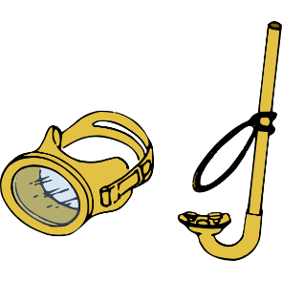

***Check out our website for all photos***

***Fall SOS was a great time!***

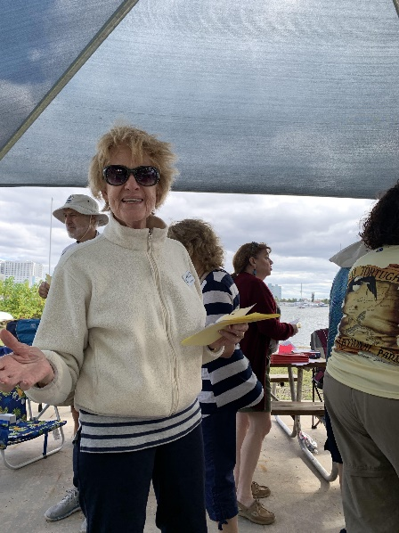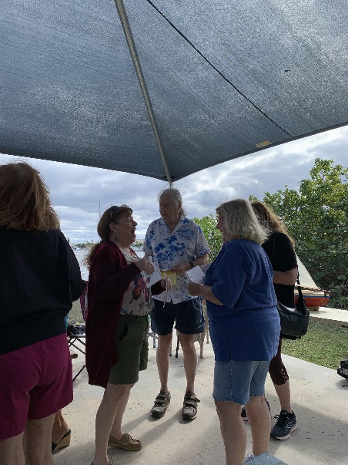

***Big thanks to Max for a great SOS!***

**Save The DATE!!!**

**Change of Command January 15**

**Embassy Suites Deerfield Beach**

**Welcome the SSSF 2022 Board of Directors**

|  |  |
| --- | --- |
| **Commodore**: Jay Thomsen  **Vice Commodore**: Susan Cohoat  **Secretary**: Elyse Greene  **Treasurer:** Nancy Widener  **Membership**: Sharon Schultz | **Newsletter**: Doug Noble  **Social Chair**: Cindy Kehoe  **Sailing Director:** Scott Stemple  **Fleet Captain:** Paul Africano  **InformationTechnology**: Cheryl Lutz |

**2021 Board of Directors**

|  |  |
| --- | --- |
| **Commodore**: Brian Brown  **Vice Commodore**: Max Goldstein  **Secretary**: Iris Voorhees  **Treasurer:** Nancy Widener  **Membership**: Carol Rapport | **Newsletter**: Linda Cusmano  **Social Chair**: Arlene Sprenger  **Sailing Director:** Rich Luce  **Fleet Captain:** Kelly Dobbs  **InformationTechnology**:Cheryl Lutz |

**Promote your business with our Business Card ads.**

