Volume XXXI Number 6 June, 2021
 | SSSF Facebook Page |  | SSSF Meet–Up Page | Sailing Singles of South Florida  Website  P. O. Box 4532,  Fort Lauderdale, FL 33338
 | Upcoming Events | July 1 - General Meeting - Bokampers July 8 - Social - Bokampers  July 15 - Social - Bokampers July 22 - Social - Bokampers  July 26 - Board Meeting – Bokampers July 29 – Social - Bokampers
Schedule of Events
Upcoming Events:
July 1 - General Meeting - Bokampers
July 3 – 4th of July Celebration at Arlene’s House
July 4 – Raft up Biscayne bay
July 8 - Social – Bokampers
July 15 - Social - Bokampers
July 22 - Social - Bokampers
July 26 – Board Meeting – TO BE RESCHEDULED
July 29 – Social & CAPTAINS MEETING FOR CIRCLE RAFTUP– Bokampers

Promote your business with our Business Card ads.
Starlight Musicals every Friday Night
Holiday Park in Fort Lauderdale

Join us for the Starlight Musicals every Friday evening beginning June 11,2021 thru August 19.
This concert series is held at Holiday Park in Fort Lauderdale every Friday evening over the summer.
Sailing Singles members are invited to attend along with Guests at no charge.
Parking is Free! Bring a dish to share and a beach chair.
Look for Jean Deering’s tent (SSSF member) and Andy Deering at the back of the field. Get there at 6:30 pm as the concerts start at 7:00 pm.
Holiday Park is located at the corner of Sunrise Blvd. and Federal Hwy. behind War Memorial.

Hope to see you there!!!
June and July Birthdays
Paul Africano – 7/19
Kenneth Bloemker – 7/27
Brian Brown – 7/07
Susan Cohoat – 7/28
Max Goldstein – 7/31
Jean Marie Gordon – 7/24
Cathy Harper – 7/02
Michael Iseman – 7/01
Rena Mamolou – 7/28
Colleen Murphy – 7/21
Gillian O’Neill – 7/16
Kenneth Tafts – 7/31
Jay Thomsen – 7/27
Sue Tracey – 7/14
Iris Voorhees – 7/10

Lilian Bracht-Kern 6/02
Jean Crocker-Deering 6/05
Debi DeKiel – 6/14
Jeannette Jordan – 6/07
Deborah Magraw – 6/24
Anita Papkov-Bloemker - 6/29
Mona Pincus 6/05
Arlene Sprenger – 6/02
Scott Stemple – 6/21
JoAnne Tanguay – 6/19
Paul Ugolini – 6/01

Upcoming August Event
Take Me Out to The Ballgame!
When : August 28, 2021
Time: Gates open at 4:10 pm Game starts at 6:10 pm
Where: Miami Marlins Park 501 Marlins Way, Miami, Fl 33125

Cost: $30.00 Ticket price includes $10.00 food and beverage voucher
Purchase tickets though SSSF website.

Parking is $15.00 per car
(payable at lot)
DEADLINE FOR REGISTRATION IS AUG. 6TH. THERE WILL BE NO EXCEPTIONS TO DEADLINE!!
QUESTIONS : CALL ARLENE SPRENGER (SOCIAL DIRECTOR) 954-566-0008
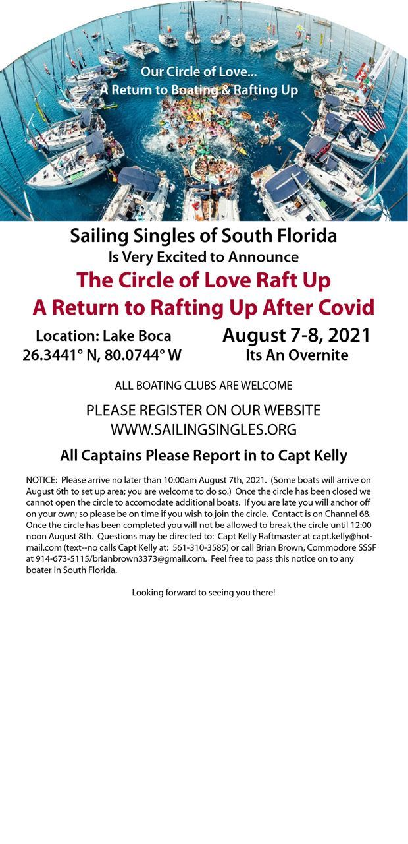
FROM THE HELM

July has been a tumulus month for the Club and I’d like to take a moment to discuss this with all of you.
We have 130 members as of this writing. They live from Miami to North of West Palm Beach. Our job as the Board is to serve all of our Members equally. Believe me, we are trying to keep the big picture in focus but as usual there are a million different opinions from Club Members.

As many of you know we are struggling to find a permanent place for us to have our Socials, General and Board Meetings. But its important for all of you to know we have some history that is making our job to do that harder and we also have so much tension in the Club over it it might fracture the Club. I really really don’t want that. We were sailing along so nicely until this point…and I’d ask the Membership to take a deep breath and think about what’s best for ALL of us.

First, the history. Our Club has a reputation with the restaurant owners in Southern Florida. Don’t think that the restaurant owners don’t talk…because they do. We are known for walking checks without paying EVERY WEEK we have the Social Meeting, yelling at the waiters, being cheap tippers, fighting with Club Members, fighting with the waiters, passing out in lobbies, stealing toilet paper and more. Look guys, its all about having fun but whatever a single Member does affects the entire Club. All of that is bad unnecessary behavior; and no one is telling you you can’t have maximum fun.

I try not to pound people on the heads about things, but this point I must drive this home. Our BAD behavior as a group must stop. We cannot walk checks…or be cheap tippers. Cheap tipping is a big no no now.

Remember, restaurants are having a really hard time finding wait staff and if WE drive off their wait staff the restaurants will throw us out. Less than a 20% tip is not cool. And I hear the people saying “why should I tip 20% if the service isn’t good?”

Well if you don’t we won’t have a place to meet. The owners of the restaurant don’t care that we’re a large group because the revenue we generate—about $500-$800 a nite. It isn’t worth losing their waiters over our cheap bad behavior. Here’s the reason: Restaurants can seat 12 couples with a $50 check and make more money profit wise on us…and their waiters get a nice tip…and no one walks the check.

The reasons listed above are why we cannot go back to the Downtowner, Flip Flops and other places we’ve been thrown out of. But with that being said its also much harder to find a venue that will be in everyone’s best interest.

So let me segue back to our struggle. We are trying to find a place that is in the middle of our geographic area…so that Club Members from Miami to West Palm can easily travel to it. Remember our Socials start at 5:30 and that’s during rush hour traffic.

Next big struggle is the money. Our Club has grown used to $3-$5 wines/beers/drinks and $6 appetizers with little or no parking fees. Well, Covid changed that. As we all know the restaurants were shut down so they are rebounding and they are pretty much all charging more. With that being said there are few places that we’ve surveyed where our Members can have a $25 check for two wines/drinks, an appetizer and parking that meet in the middle of the geographic zone. That’s the reality of what we are facing.

So with all of that being said I am going to ask the Membership to hang tight…and wait until August 15th when we will all vote for a place to hold our meetings. But you should know that we will NEVER find the deal we had at Flip Flops where you could have three drinks, an appetizer, with parking and walk out for $20. It just isn’t happening folks.

In the meantime I’d ask those Club Members that are making such a big deal out of this—which is causing some fracturing in the Club—to take a step back and view what is good for the Club and not their interests. It’s important that we consider everyone and every option. I am getting pounded almost daily by a quite a few people to choose what they want. To me what’s important is what the Club needs—personally I don’t care where we meet as long as it fits the needs of the Club. I’m happy just seeing my fellow Boaters and Club Members.

Thanks for your patience, understanding and faith in our Board. We’ve accomplished a lot and have a lot more to do. But I will guarantee you all this: When we pass the torch on to the new Commodore and Board the Club will be in a better position than we were before. My job is to make sure the legacy of the Club continues along the right path and we are taking that extremely seriously.

BRIAN
From the Helm

JULY 3 POOL PARTY

As always a great time was had at the celebration of 4th of July at Arlene Sprenger’s house. The grills were going and the pool was filled with members!

Thanks to all the helpers, especially Paul Africano for his grilling expertise and Arlene for the use of her home and the hours she spent to get everything perfect!

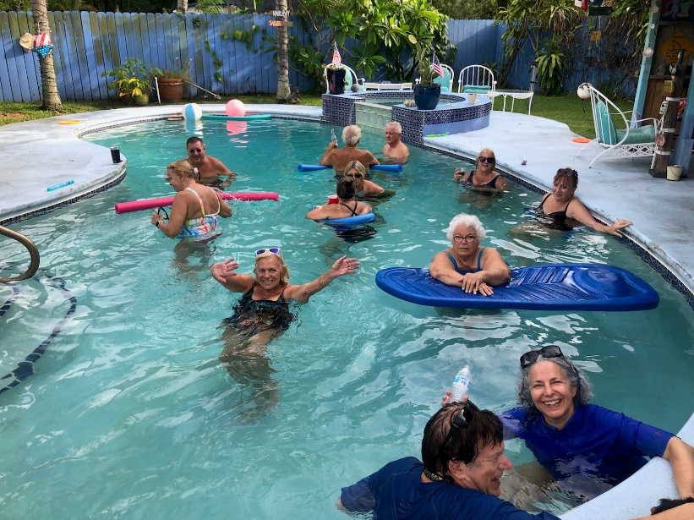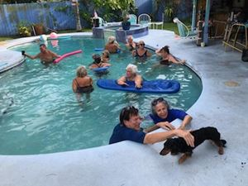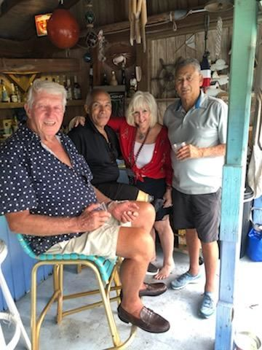
All the photos are available on the website.

Welcome the SSSF 2021 Board of Directors

Commodore: Brian Brown  Vice Commodore: Max Goldstein  Secretary: Iris Voorhees  Treasurer: Nancy Widener  Membership: Carol Rapport | Newsletter: Linda Cusmano  Social Chair: Arlene Sprenger  Sailing Director: Rich Luce  Fleet Captain: Kelly Dobbs  InformationTechnology:Cheryl Lutz

